There are 8 pages containing examples of results and visualizations that I hope to generate.

RESULTS
3. Client-Side Results
3a. Local Feature Selection or Ranking. Present top-N features for each client with visualizations such as:
- Feature importance bar plots for each client based on local model.
- Heatmaps of selected features across clients.
- Correlation plots.
(Optional, any consistency across different feature selection methods (if multiple)?)

Exemplary visualization:

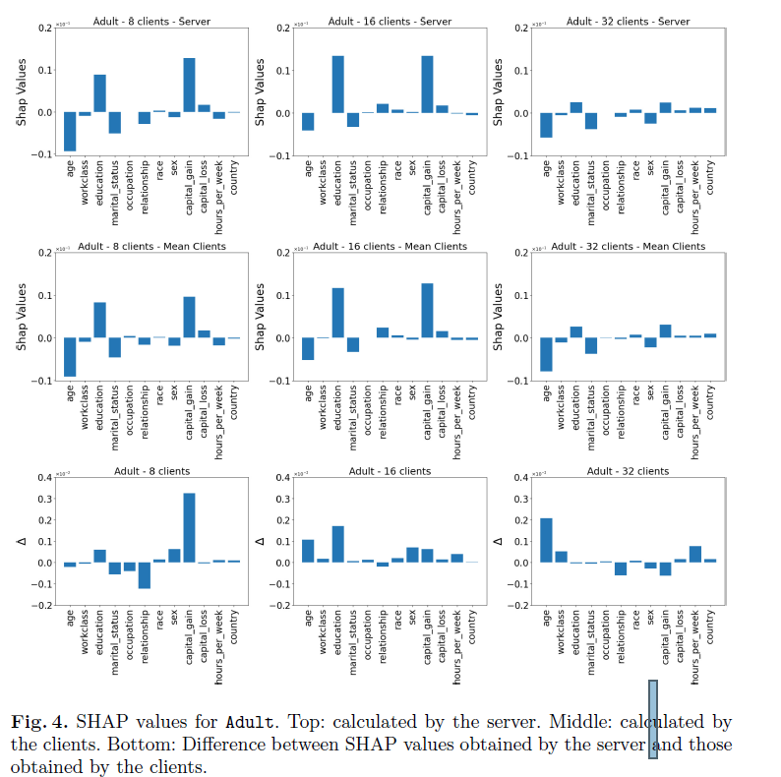

From: Luca Corbucci, “Explaining Black-Boxes in Federated Learning” https://www.dropbox.com/scl/fi/c70g773hgk0quf4azohkp/1-SHAp-for-client-n-server-feature-explanatibility.pdf?rlkey=hk60gl9o5qtijdsk8mdodholx&dl=0

3b. Local Model Performance & Visualizations
Report for each client / each model:
- Table for the train/test performance (mean ± SD across folds or repeated runs) and suggested plots:
- ROC curves / PR curves.
- Regression scatter plots (predicted vs. actual).
- Confusion matrices.

Exemplary visualization:
  - 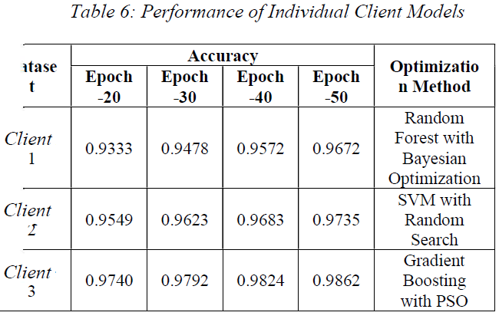

  - https://www.dropbox.com/scl/fi/bp9v044fv04cggf35sh70/000-Exact-flow-and-topics-an-results.pdf?rlkey=d98bcm87gedmx7qh7vz2nbdm8&dl=0

4 Federated (Server-Side) Results
4a Federated Model Performance. Present results with:
- Table of train/test performance (mean ± SD).
- Performance change across communication rounds (learning curve).
- Comparison charts: federated vs. local model performance.

Exemplary visualization:
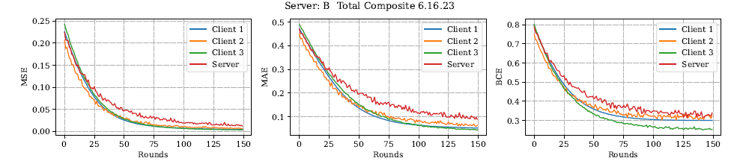
- Figure: Comparison of federated vs local model training performance. (Add validation performance as well).

Exemplary visualization:

  - 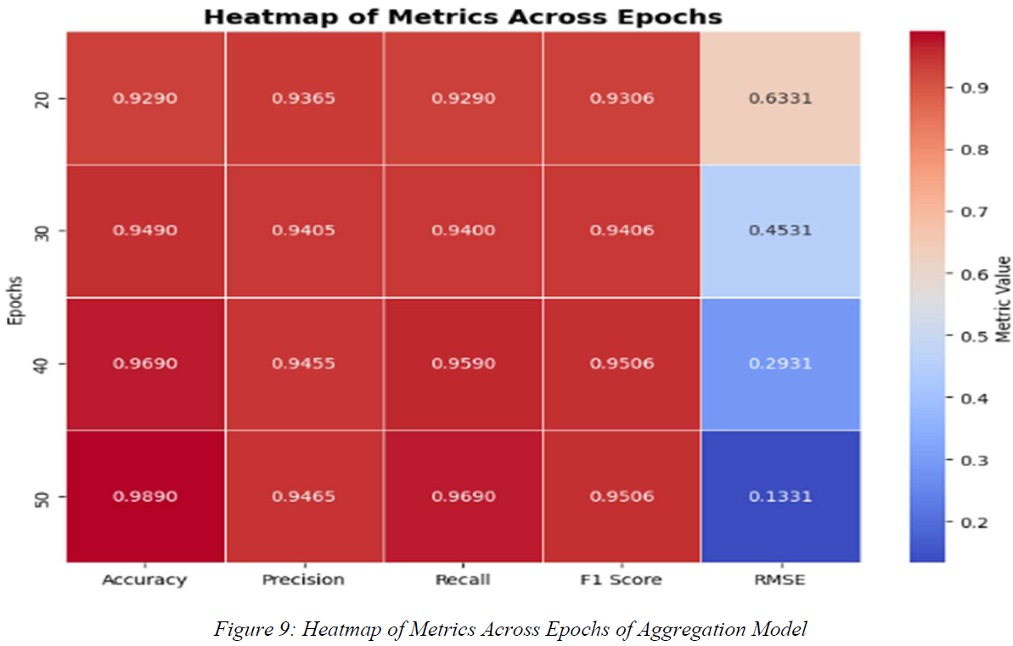
  - https://www.dropbox.com/scl/fi/bp9v044fv04cggf35sh70/000-Exact-flow-and-topics-an-results.pdf?rlkey=d98bcm87gedmx7qh7vz2nbdm8&dl=0

4b Federated Feature Selection or Ranking. Present results with (suggested plots):
- Global feature importance (rank list) bar chart.
- Performance-over-rounds curve.
- Overlap analysis (Venn diagrams) between federated and local features.

Exemplary visualization:
  - 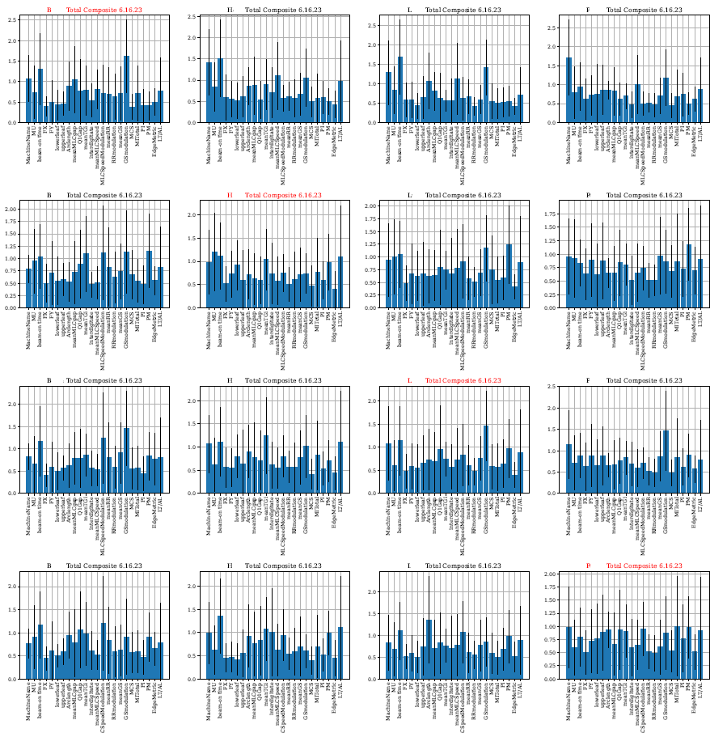

4c Payoff (contribution) from each client towards the Federated model :

Exemplary visualization:

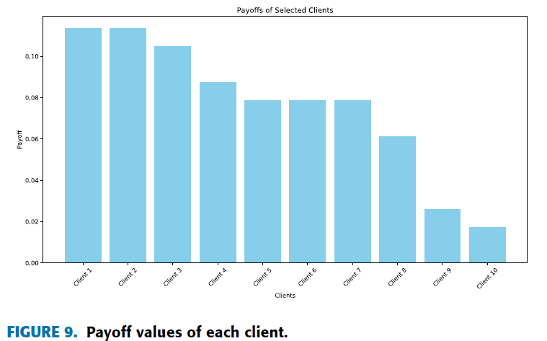
Y. SUPRIYA AND RAJESWARI CHENGODEN, “Breast Cancer Prediction Using Shapely and Game Theory in Federated Learning Environment” https://www.dropbox.com/scl/fi/gyaxj75ruj4qmrswgckum/1-Shapely_and_acc-vs-rounds-plots.pdf?rlkey=f7vesn4bhpqr4sq1obp9hwn0x&dl=0

4d Payoff /fitness score from each client towards the Federated model :

Exemplary visualization:
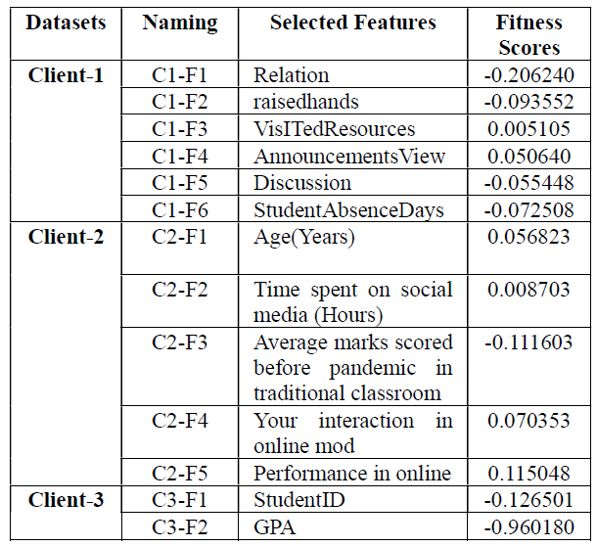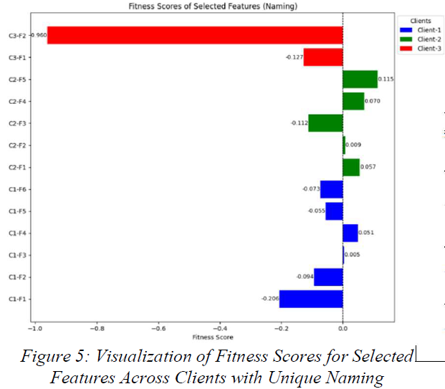

https://www.dropbox.com/scl/fi/bp9v044fv04cggf35sh70/000-Exact-flow-and-topics-an-results.pdf?rlkey=d98bcm87gedmx7qh7vz2nbdm8&dl=0

4e Comparison of local vs federated training parameters:

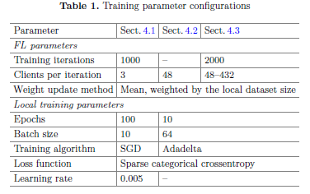
https://www.dropbox.com/scl/fi/s5h02r6dj1csjksbf9qjf/1-Training-parameter-summary.pdf?rlkey=8qjwvlxaewucw33l41iip2rku&dl=0

5. Validation: Applying Federated Model Back to Each Client
After the federated model & feature set are optimized:
5a Cross-Client Validation Using Global Features
For each client:
- Apply federated-selected features (using each client’s local feature values).
- Evaluate performance using the global federated model.
- Compare:
  - Performance using federated model + global features
  - Performance using local model + local features (obtained from step 3b above)
Suggested plots- Bar chart comparing:
  - Local model accuracy vs. federated model (client-specific predictions).
  - Scatter plots of regression predictions.
- Summary performance table.
- Statistical significance testing (optional, e.g., paired t-test to test if difference b/w federated and local model are significant).

Exemplary visualization:

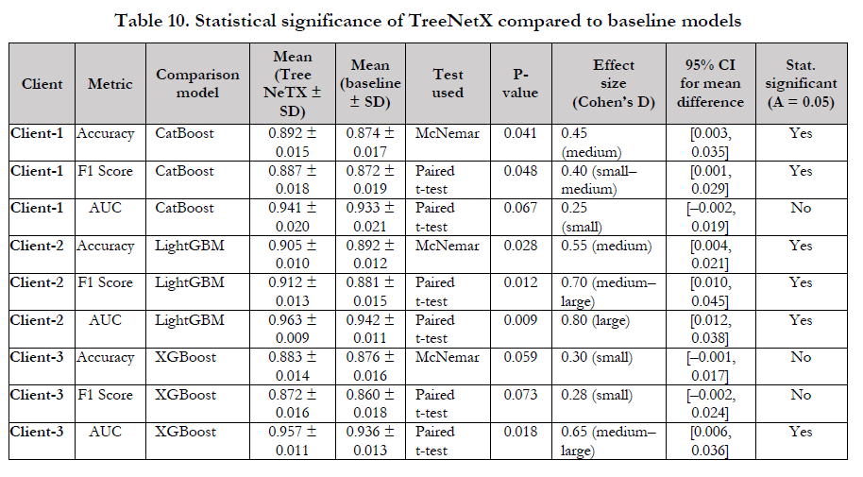

https://www.dropbox.com/scl/fi/6yhibkgegy99u1ax0lmo9/000-Exact-flow-and-topics-FEDERATED-TREE-BASED-ENSEMBLES-WITH-SHAP-for-Lung.pdf?rlkey=aw208wjycrqk2hvgcq9xjipfx&dl=0

6. Optional but Valuable Additions
Ablation Studies
- 6a. Compare individual client model vs. federated vs. centralized training (if data sharing allowed as a simulation).

Exemplary visualization:

- 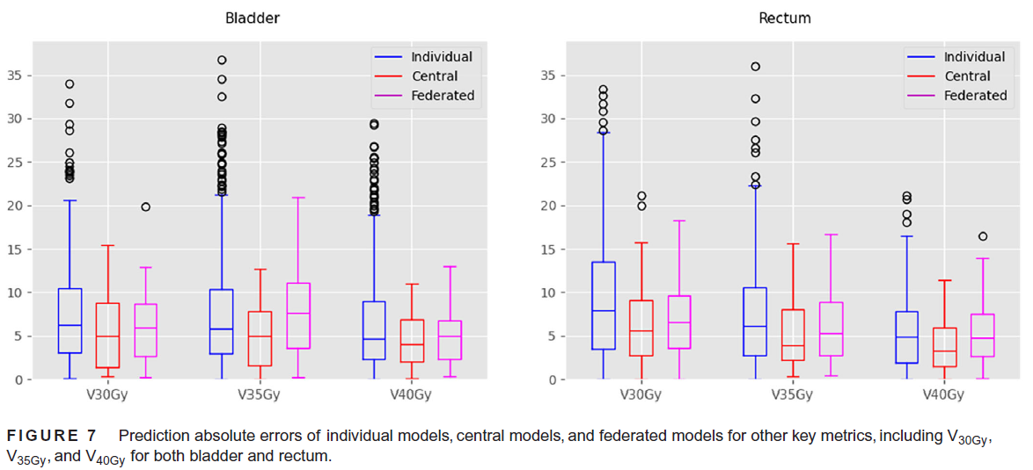

From : https://www.dropbox.com/scl/fi/8p364ln1osvb1fb39m63v/0_most-relevanat-figs-_2024-MPhys-FL-for-enhanced-DVH-parameter-predict.pdf?rlkey=gmq2yfu3wzoro7lb0m76lylzj&dl=0

- 6b. Compare performance with different numbers of global features.

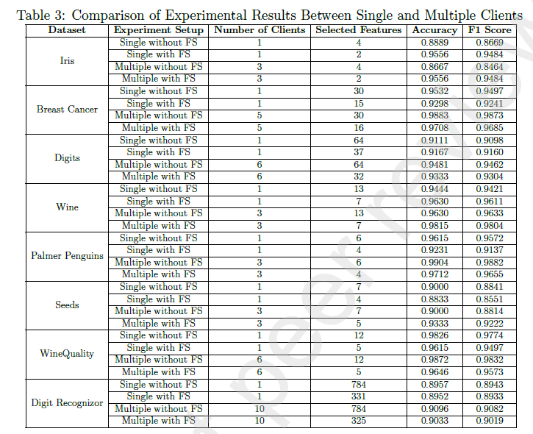
Chi Zhang “A Federated Learning based Online Feature Selection Algorithm for Streaming Data”
https://www.dropbox.com/scl/fi/fj9v4yimetojh2ujcsvxf/1-good-description-of-flow-feat-select-from-local-n-global-n-online-dynam.pdf?rlkey=umcpldv3hejhsd27vou7d5cjg&dl=0

